**1. Strive for Consistency**

Whether it is the layout, the size of the button, the color code or the tone used when writing the page, it is important to be consistent throughout the site. This consistency will allow you to develop your identity and not lose users as they navigate your site.

In the example below, you can recognize Amazon, by applying this first heuristic, there is a consistency between all the pages present on Amazon, the layout is the same, the size of the button is always similar, and the color code are very specific to Amazon.

## 2. Enable Frequent Users to Use Shortcuts

Allow your users to access all parts of the website with a minimum of clicks. To do this, you not only need to establish a good hierarchy in the menu, but also make things clear.

You should think about incorporating features for advanced users and for beginners for example, with keyboard shortcuts or macro facilities, as for example with Canva which allows its users to use shortcuts to copy and paste.

## 3. Offer Informative Feedback

If your users have performed or are performing actions on your website, it is best to display feedback immediately so that they have an idea of where their processes are

Next, we'll take an example with a tool that many professionals use, Google Drive:

* For this example, you will have to create a new folder that you can delete right after.
* When you are in this folder, choose a document of your choice, a photo, a video, a PDF file and use drag and drop to transfer it to your folder.
* Once your transfer is in progress, this window will appear to keep you informed of the progress of your transfer.

**4. Design Dialog to Yield Closure**

Remember to close any interaction made with a user based on the cause of the interaction :

* Thank you message.
* Validation message.
* Summary message during a purchase.

## 5. Offer Simple Error Handling

A good interface should be designed to avoid errors as much as possible. However, if something goes wrong, your system should make it easy for users to understand and resolve the problem. Simple ways to deal with errors include displaying clear error notifications and descriptive hints to resolve the problem.

For example, on our site, we tell you when you log in if your login information is wrong.

## 6. Permit Easy Reversal of Actions

Immediately discovering that it is easy to choose "Cancel" after making an error is a very good thing for the user. If your users know that there is an easy way to solve a problem, they will feel less anxious and more willing to explore the options.

The rule can be applied to all operations or groups of operations.

For example, here we are in the Outlook mobile application, when archiving an email, a small window automatically appears at the bottom of the screen offering to cancel the archiving.

## 7. Support Internal Locus of Control

We need to give control and freedom to the users, so that they can feel that they are in control of the system themselves, giving them some form of free will helps to reassure the user.

For example, in the screenshot below we are on Capian's YouTube page, and we can choose to turn on notifications or not, YouTube lets us choose how much notification we want to see, by doing this, YouTube is giving freedom to the users and m

## . Reduce Short-Term Memory Load

The limitation of human information processing in short-term memory requires that displays be kept simple, multiple page displays be consolidated, window-motion frequency be reduced, and sufficient training time be allotted for codes, mnemonics, and sequences of actions.

Avoid overloading your site or application with information of the same level. You have to deduce which ones should be placed first or you will lose the user's attention. No matter where you place your site, whether it's the home page or the menus, make sure that your user can't be distracted by unnecessary information.

For example, Capian's home page below is very minimalist and allows the user's attention to be focused on the "call to action", most of the information we want to promote is on the page without any other information that could disrupt the user's navigation.

### GUI Design Principles,Characteristics of good design,goals of ui design and characteristics of ui design

|  |  |  |  |  |  |  |  |  |  |  |  |  |  |  |  |  |  |  |  |  |  |  |  |  |
| --- | --- | --- | --- | --- | --- | --- | --- | --- | --- | --- | --- | --- | --- | --- | --- | --- | --- | --- | --- | --- | --- | --- | --- | --- |
| |  |  |  | | --- | --- | --- | | **Principle** | **Description** | **Example** | | **Visibility** | Clarity | Is the goal obvious? Icons used? | | **Feedback** | Information sent back to user after their action | Sound? Label showing success or failure? | | **Affordance** | How clear is the use of an element to the user? | Label “Push” on one side of a door; a button saying “Click Me” | | **Simplicity** | KISS (“Keep It Simple and Sweet”) principle | Place an Open File option on a menu, under File tag | | **Structure** | Are the elements set out in a meaningful way from the perspective of the user? | Group information within a dialogue box. | | **Consistency** | How easy is it to learn and remember the appearance, positioning and behavior of the elements? | [X] to close a window is always on top right hand side of the window; the most important buttons are the same size with only labels indicating different goals. | | **Tolerance** | Prevents user making errors or provides easy recovery or graceful fail | Ignoring of wrong or invalid keyboard input; | |

**Characteristics of GUI and Web Page**

| **Content** | **Graphical User Interface** | **Web Page Design** |
| --- | --- | --- |
| Devices | User hardware variations limited.,Screens appear exactly as specified. | User hardware variations enormous. Screen appearance influenced by hardware being used. |
| User Focus | Data and applications. | Information and navigation. |
| Data /Information | Typically created and used by known and trusted sources.,Typically placed into system by users or known people and organizations.Typically organized in a meaningful fashion.A notion of private and shared data exists. | Full of unknown content. Source not always trusted. Often not placed onto the web by users or known people and organizations. Highly variable organization. Privacy often suspects. |
| User Tasks | Install,configure,personalize,start,use,and upgrade programs.,Open, use and close data files. | Link to a site,browse or read pages,fill out forms,register for services,participate in transactions,download and save things. Movement between pages and sites very rapid. |
| User’s Conceptual,Space | Controlled and constrained by program. | Infinite and generally unorganized. |
| Presentation Elements | Windows, menus,controls, data, toolbars, messages, and so on.,Many transient, dynamically appearing and disappearing.,Presented as specified by the designer.,Generally standardized by toolkits and style guides. | Two components browse and page.Within page,any combination of text,images,audio,video and animation. May not be presented as specified by the designer dependent on browser,monitor, and user specifications. Little standardization. |
| Navigation | Through menus, lists, trees, dialogs, and wizards. Not a strong and visible concept. | Through links, bookmarks, and typed URLs. Significant and highly visible concept. |
| Context | Enables maintenance of a better sense of context.Restricted navigation paths. | Poorer maintenance of a sense of context. Unlimited navigation paths. |
| Interaction | Interactions such as clicking menu choices, pressing buttons, selecting list choices, and cut/copy/paste occur within context of active program. | Basic interaction is a single click. This can cause extreme changes in context, which may not be noticed. |

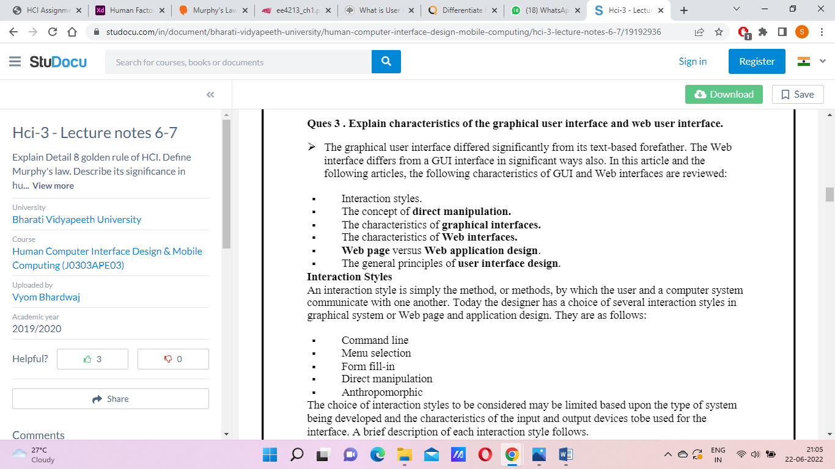

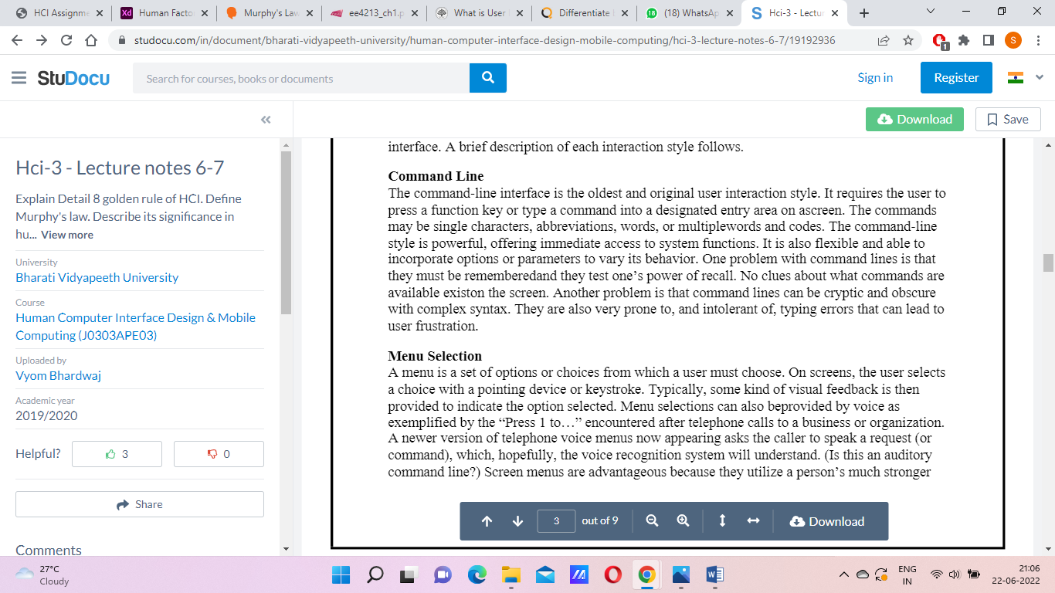

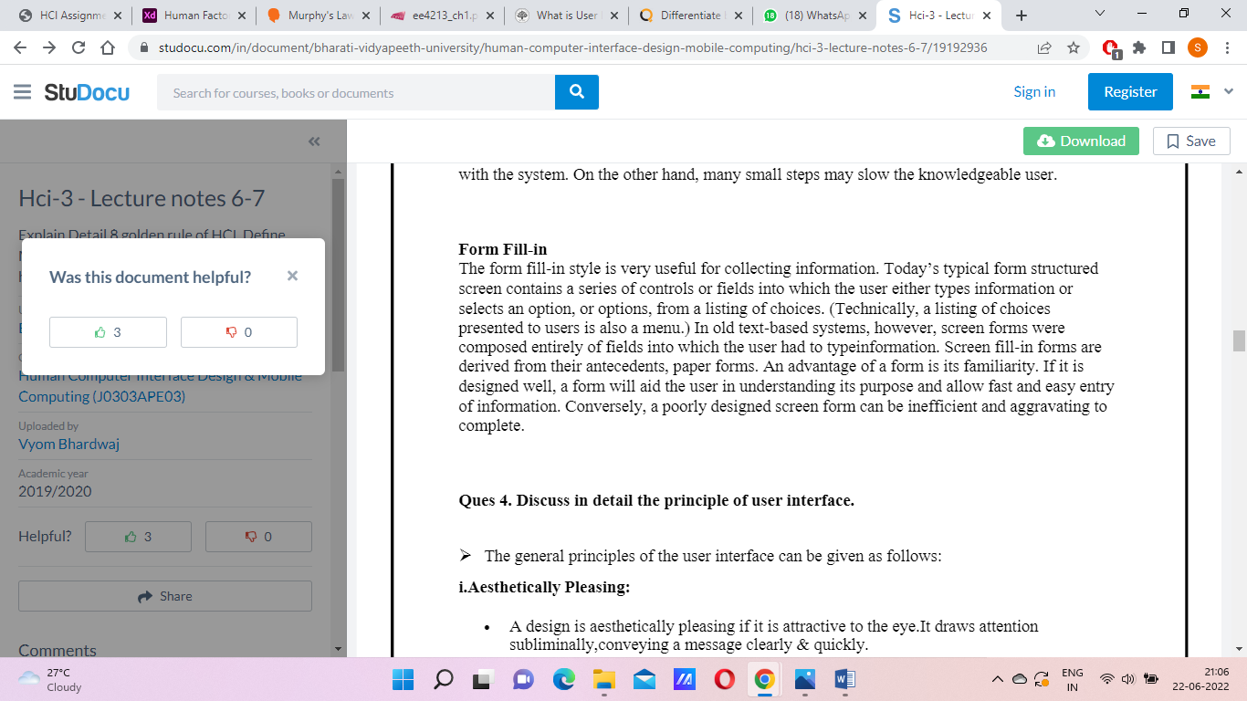

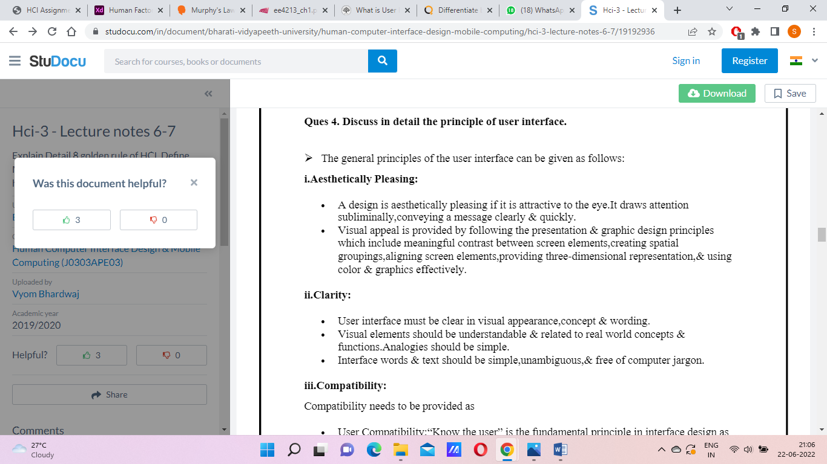

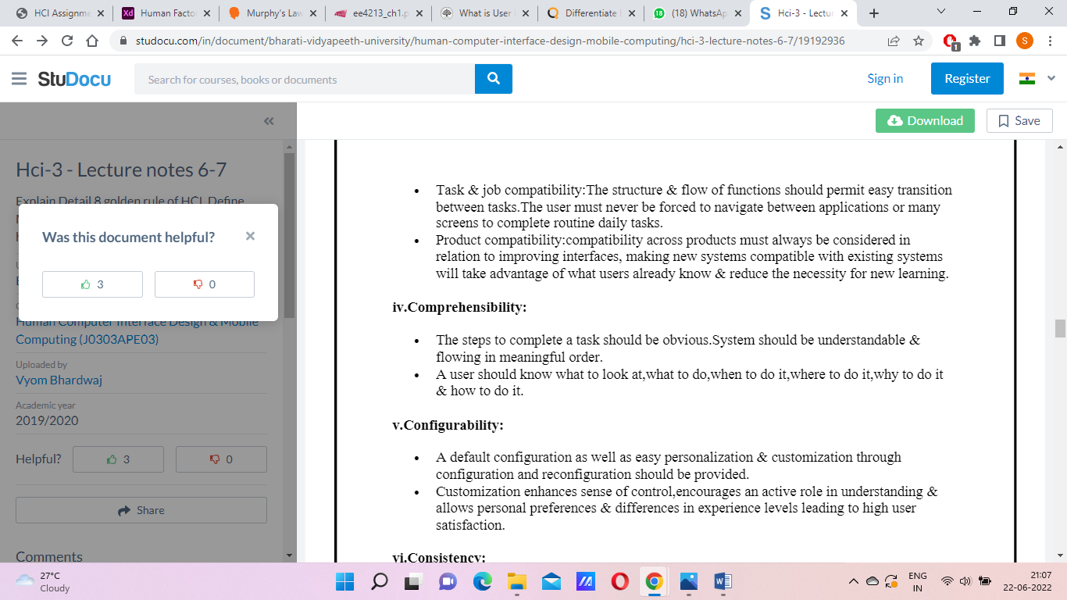

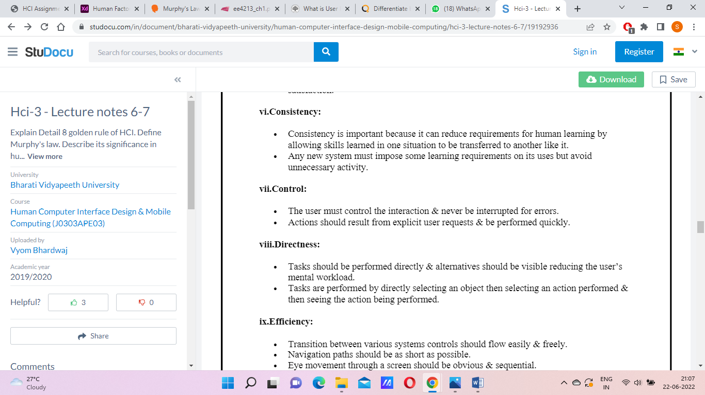

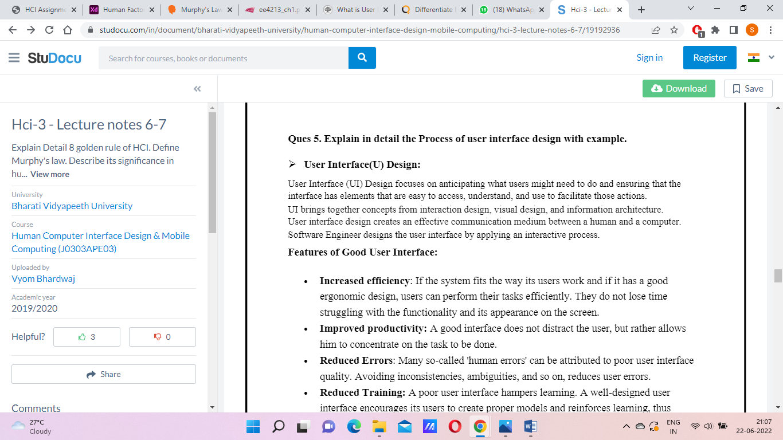

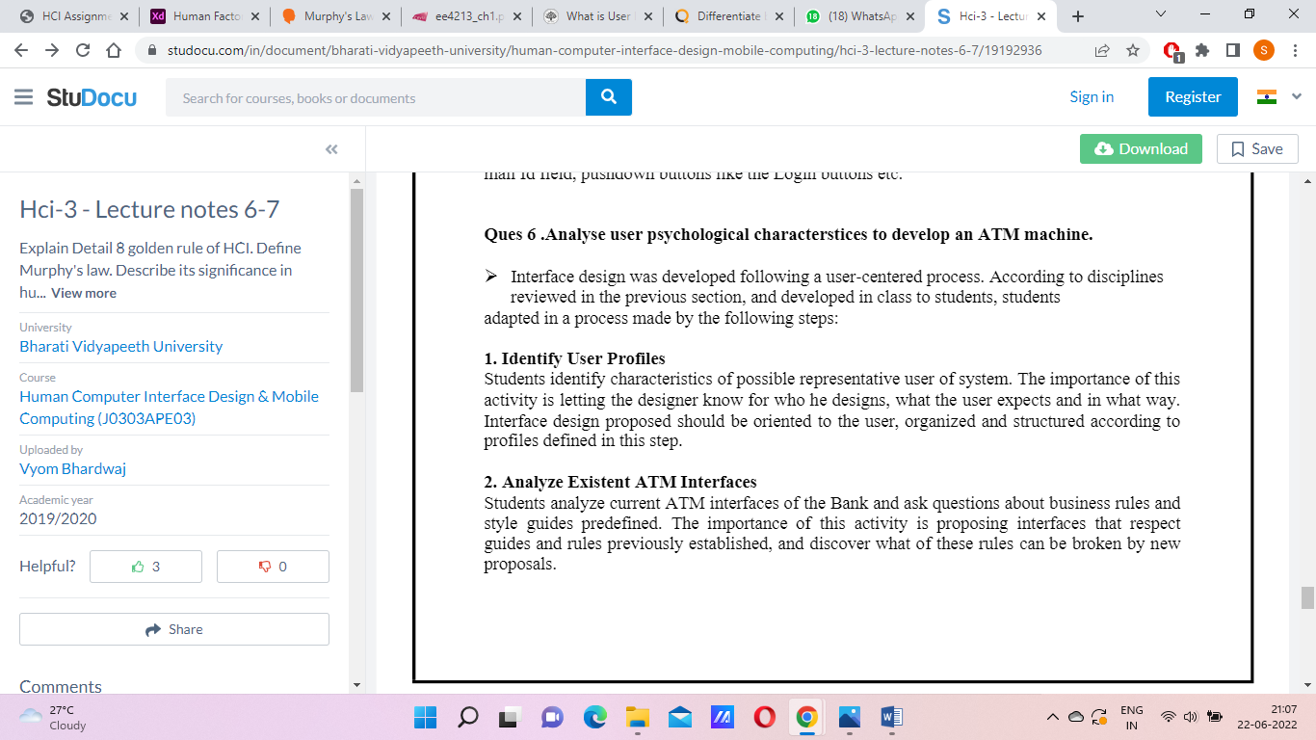

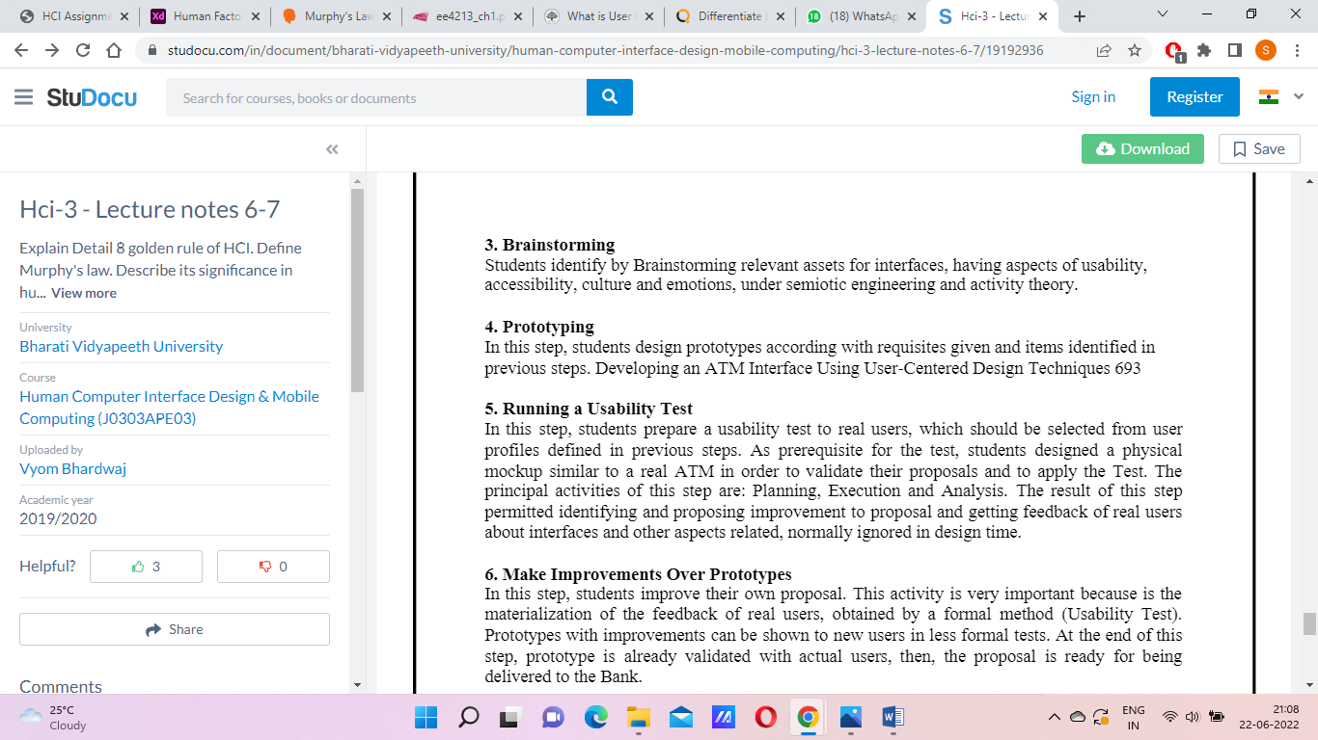

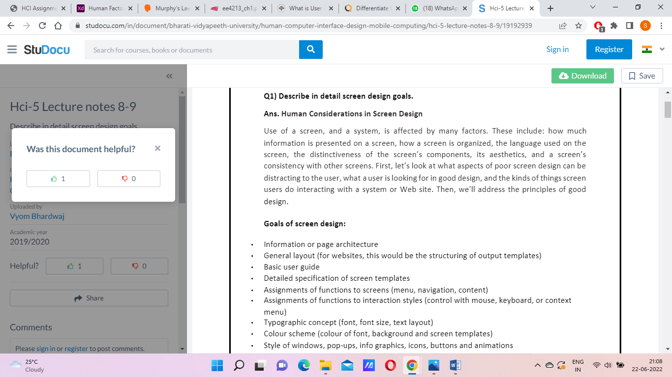

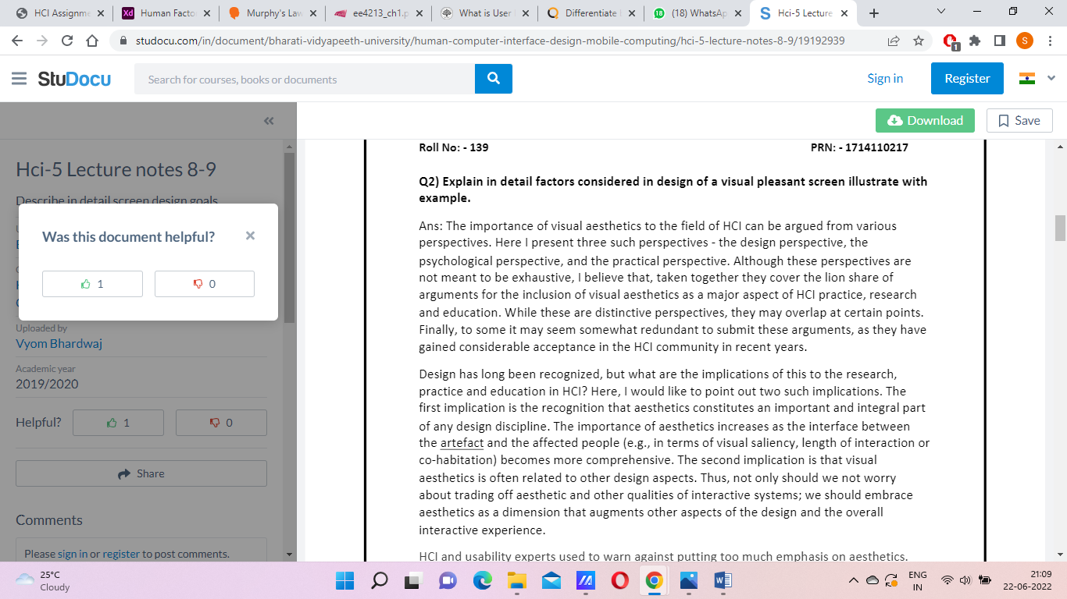

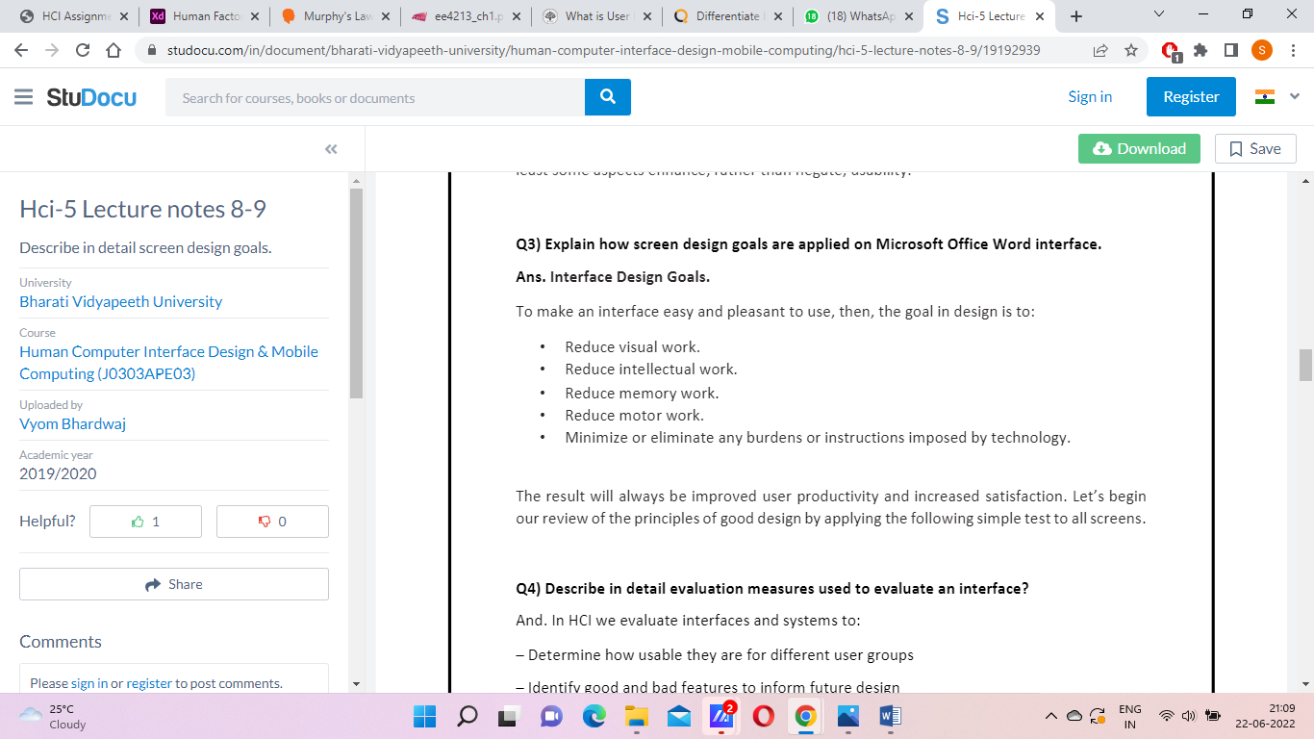

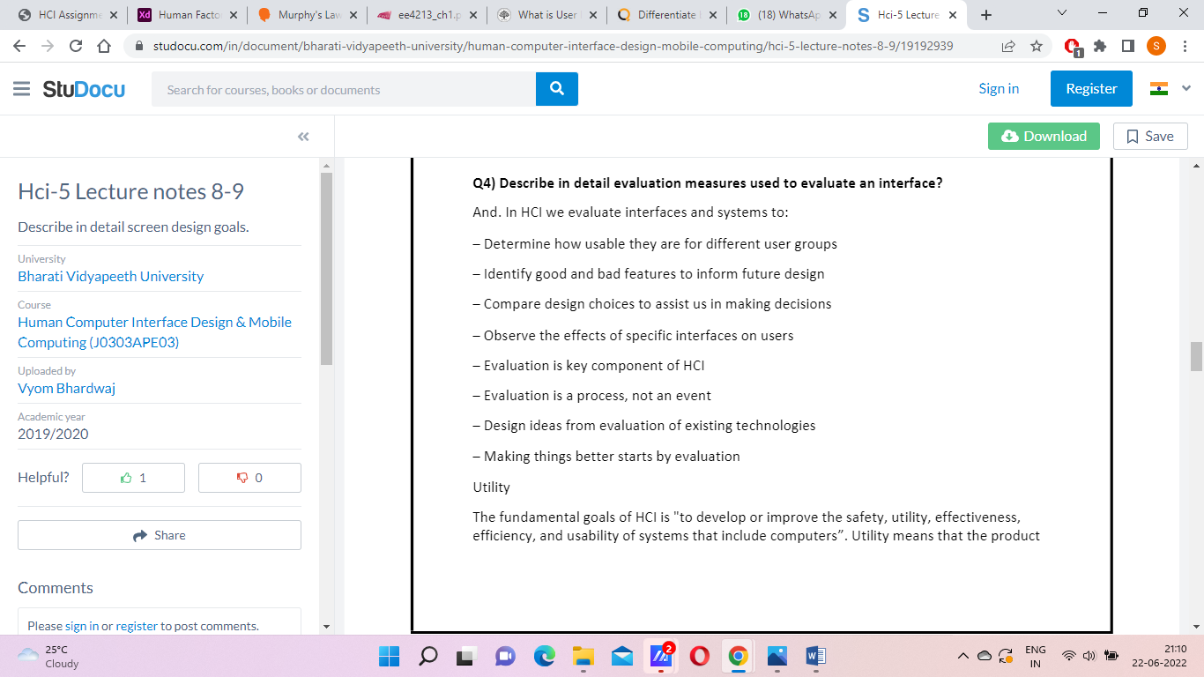

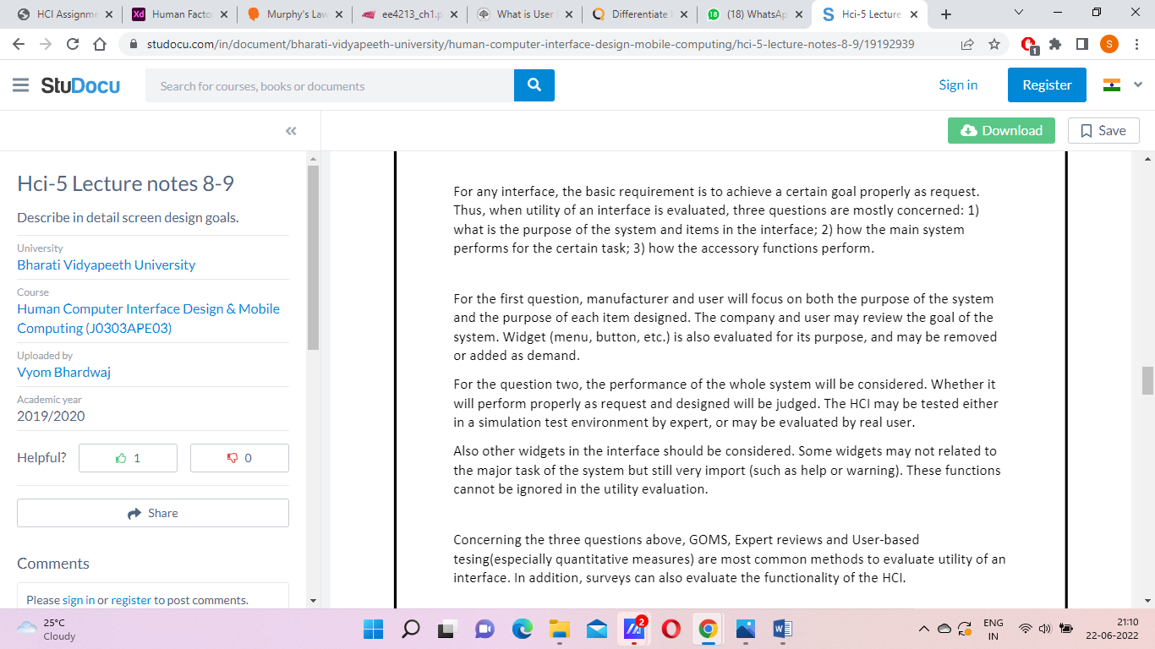

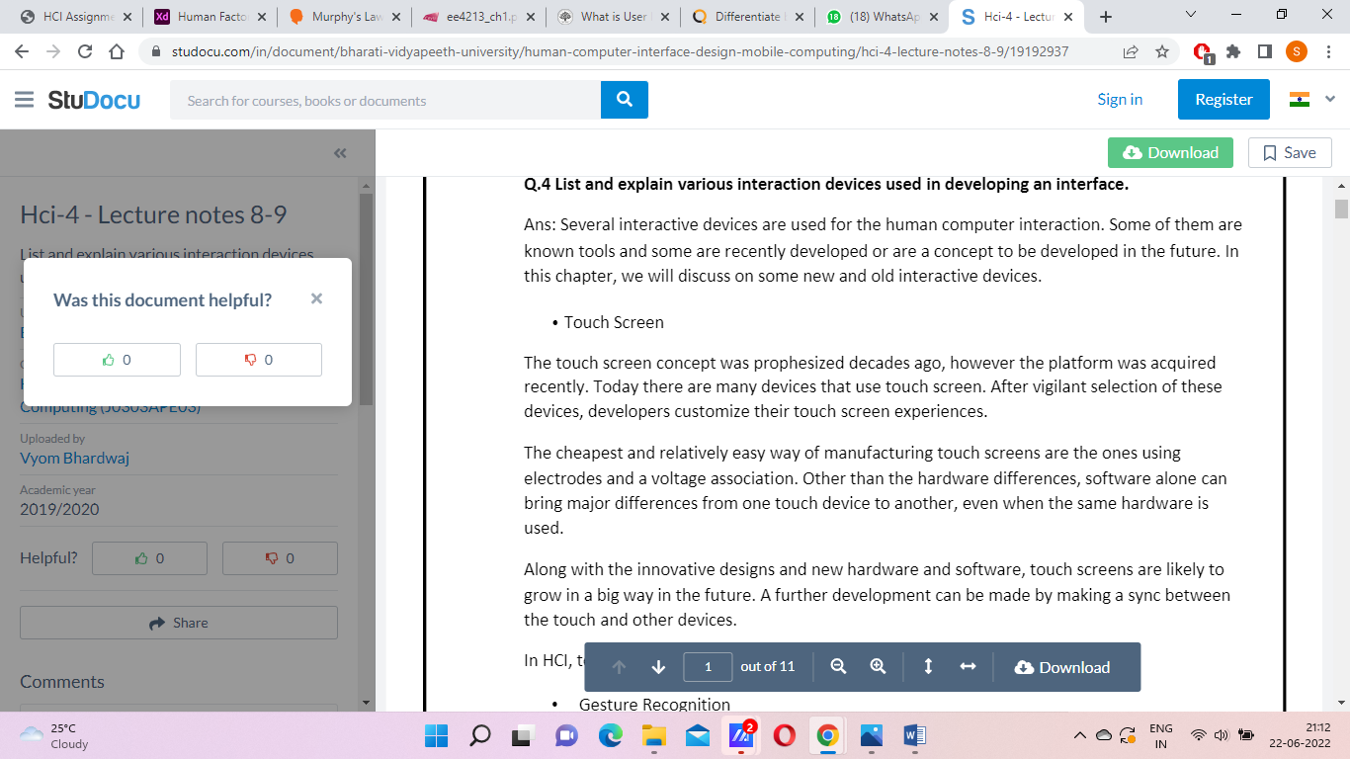

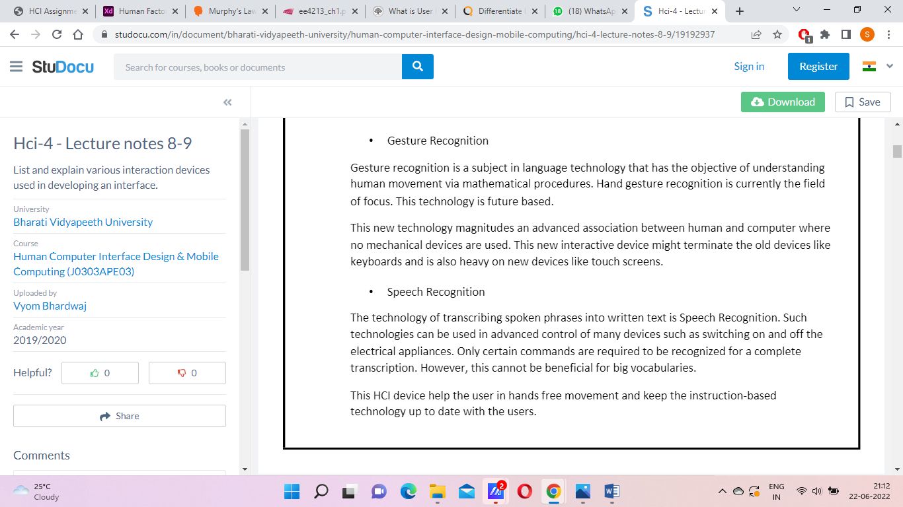

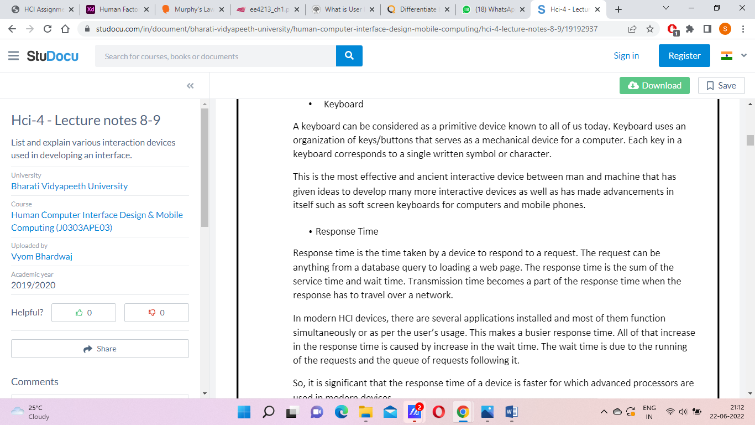

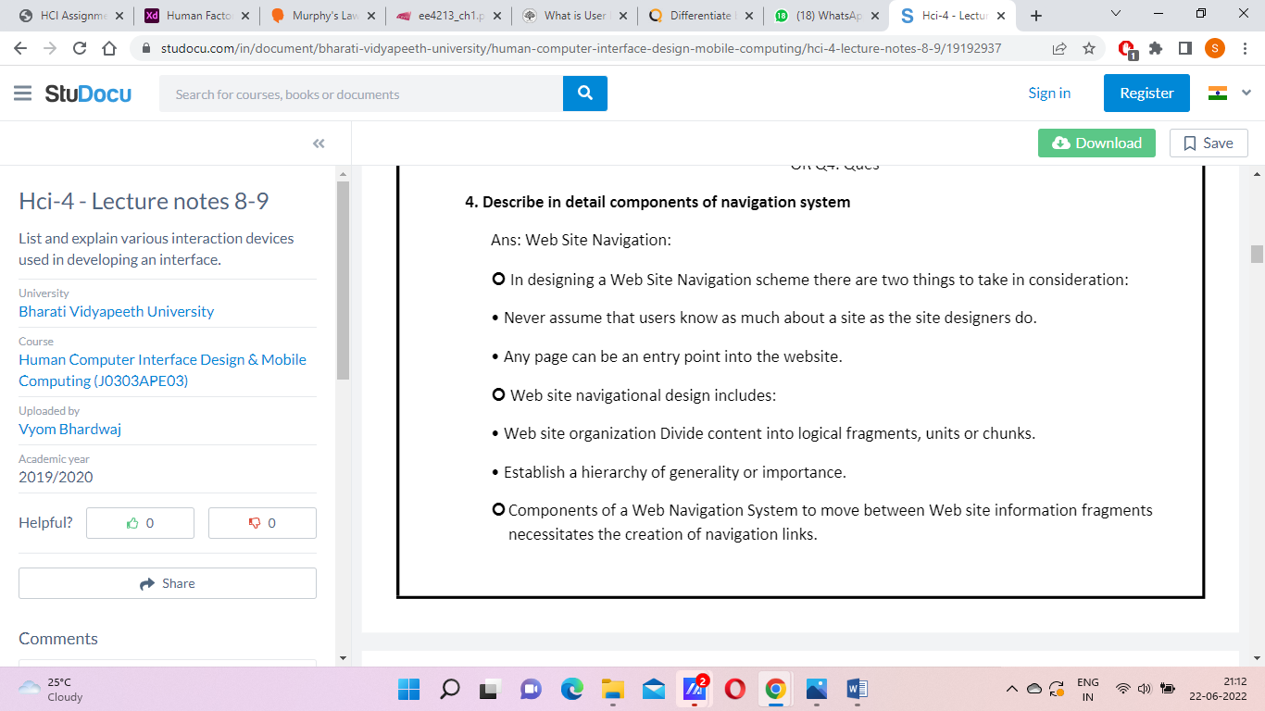

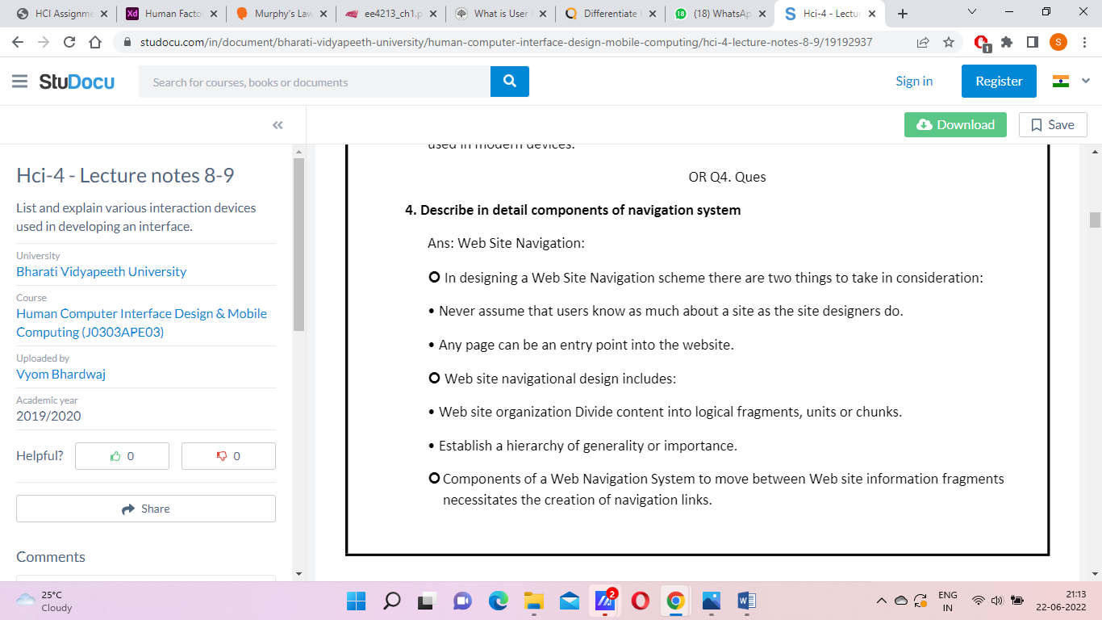

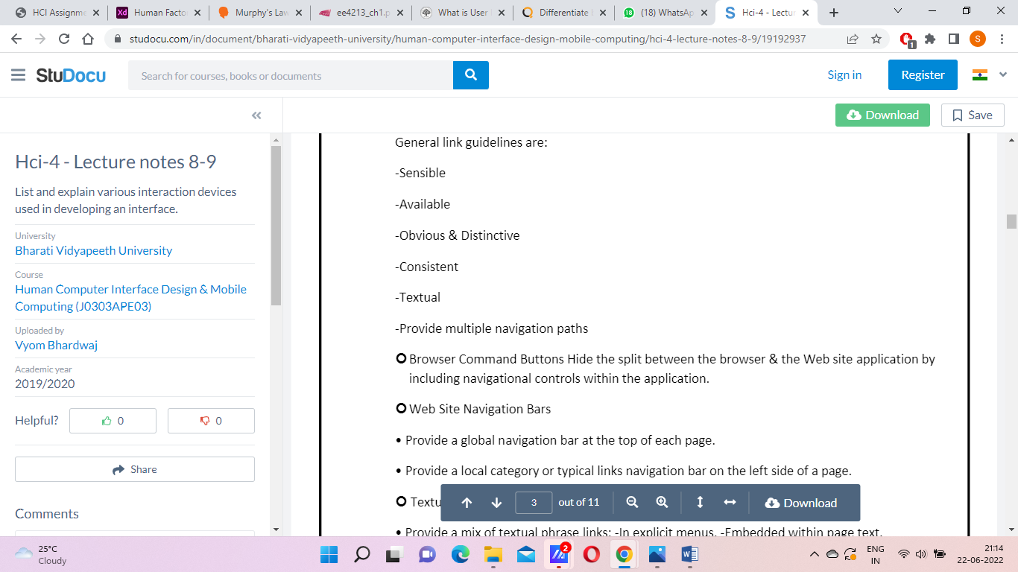

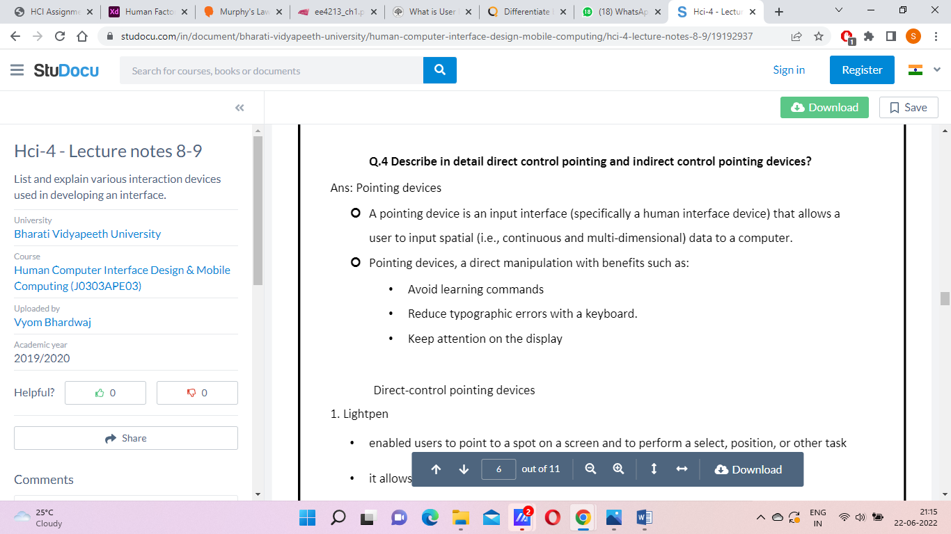

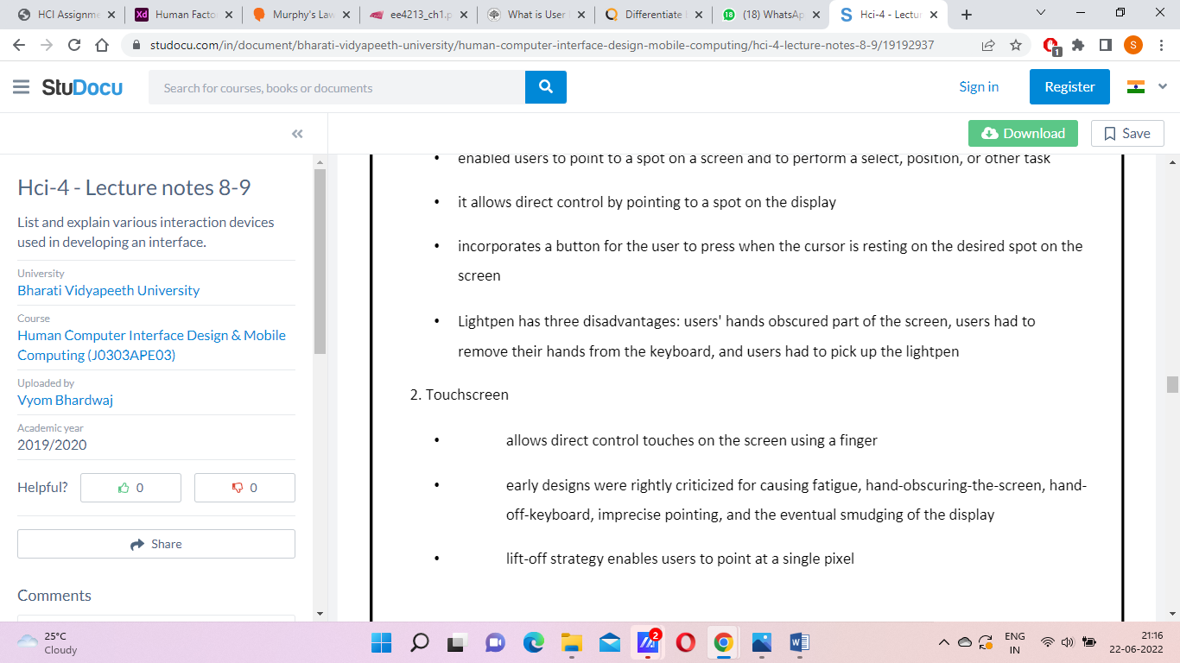

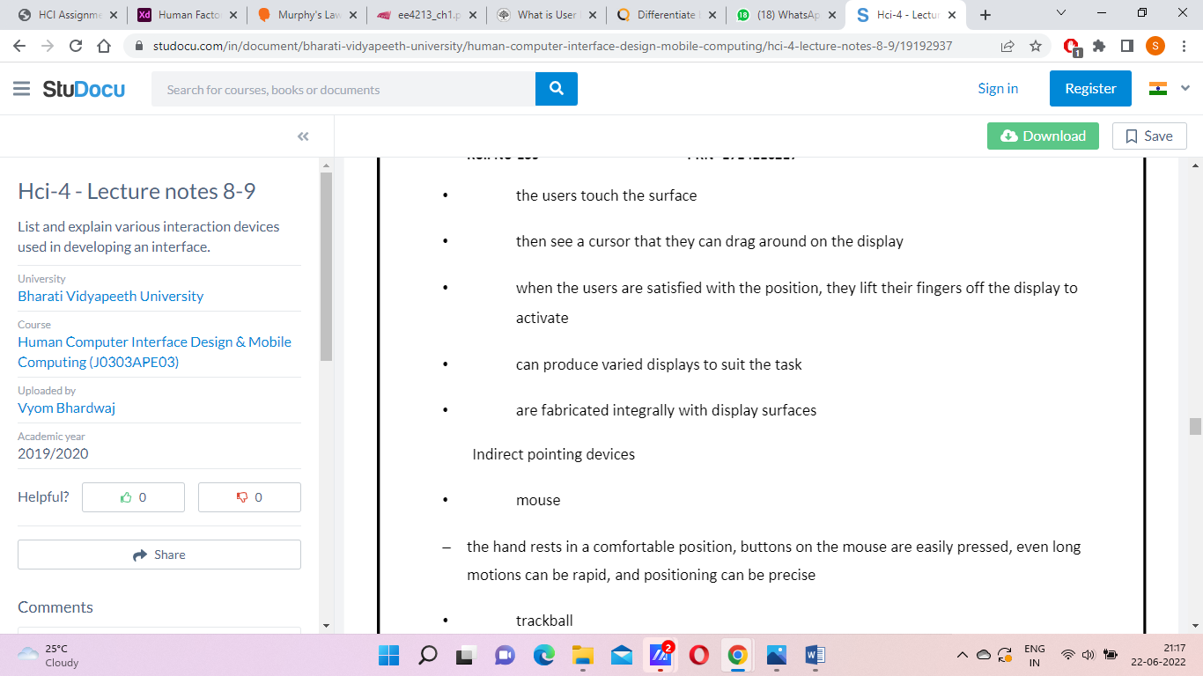

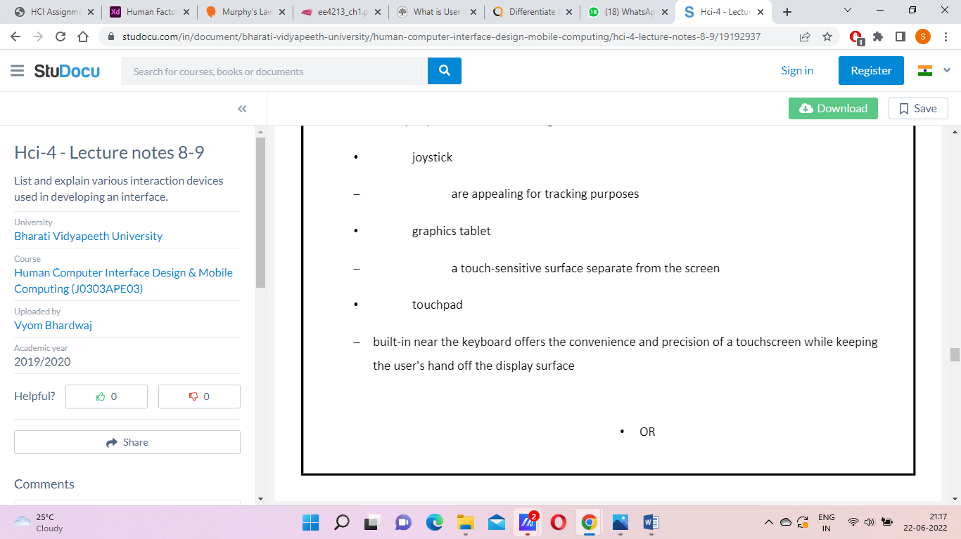

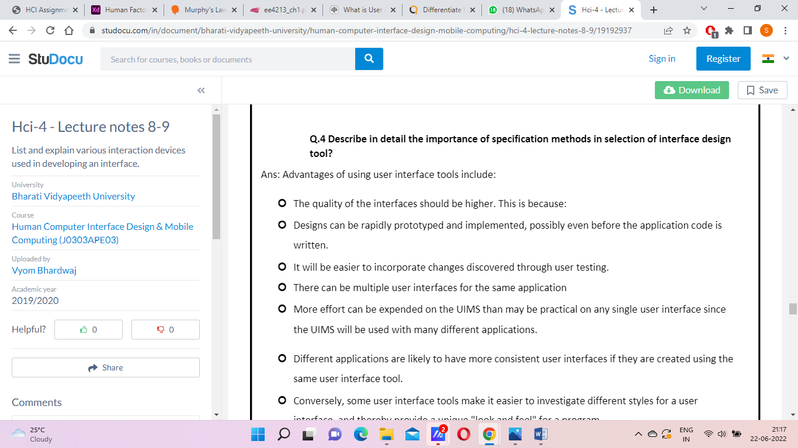

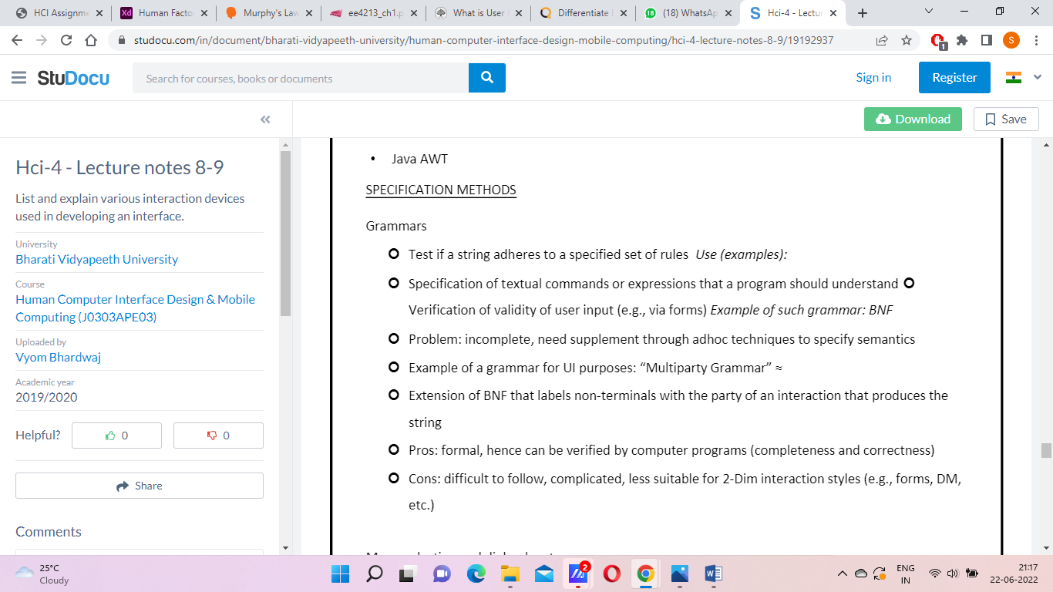

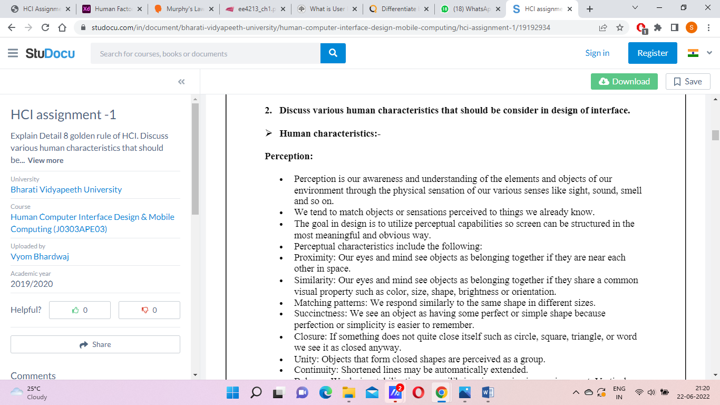

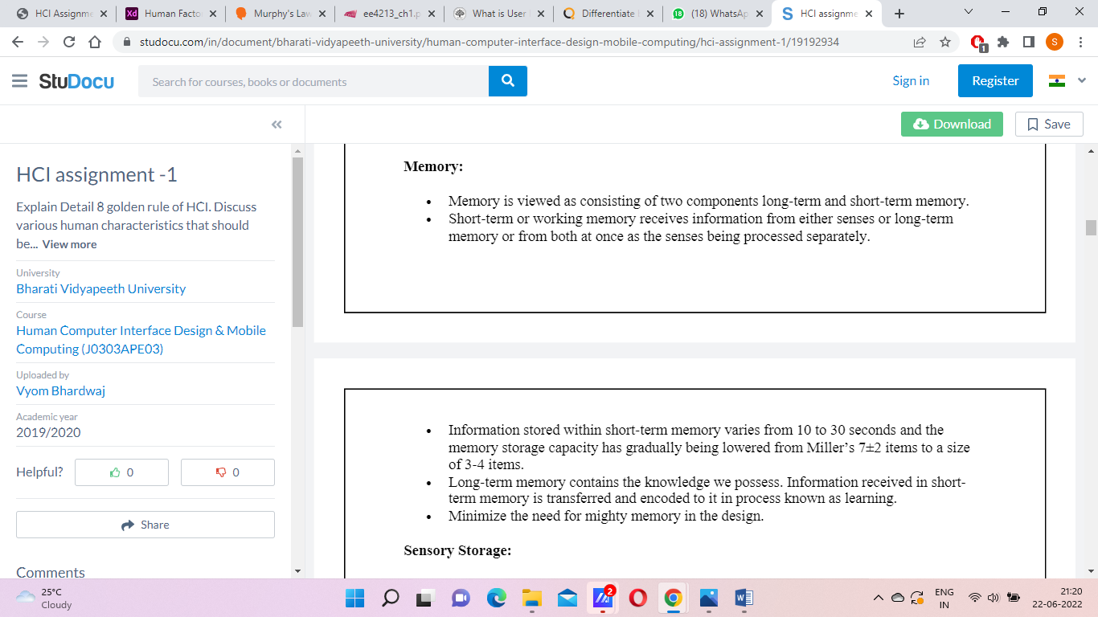

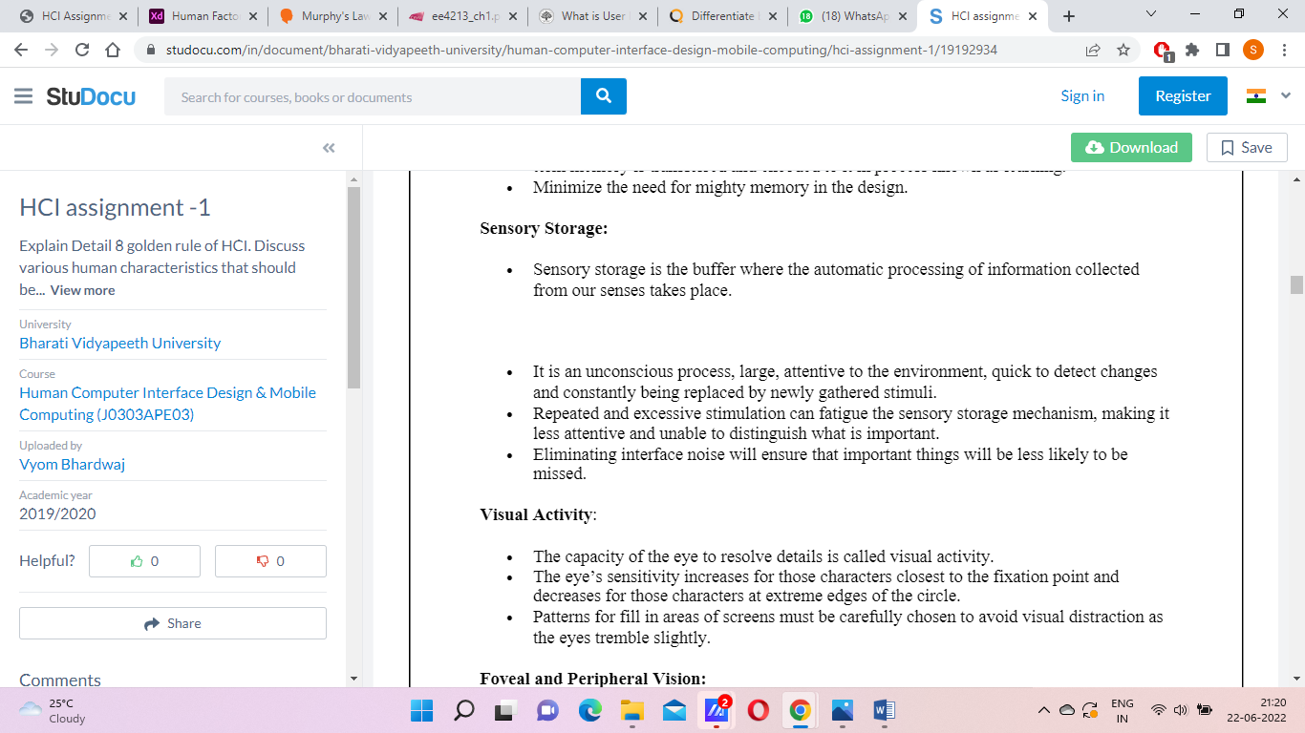

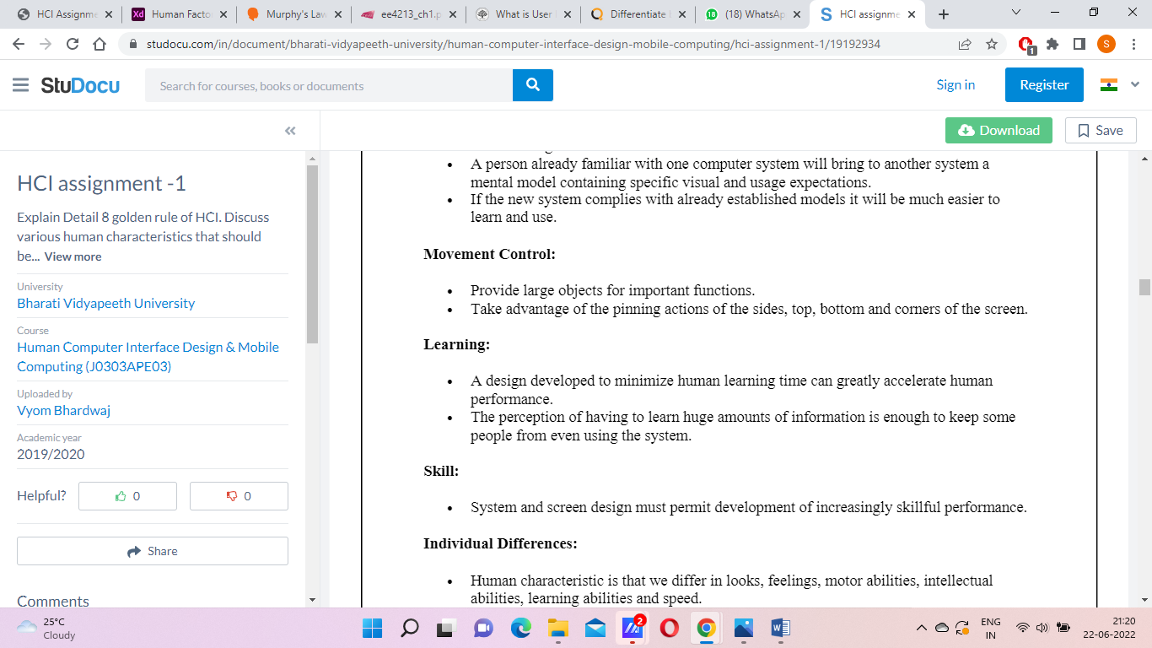

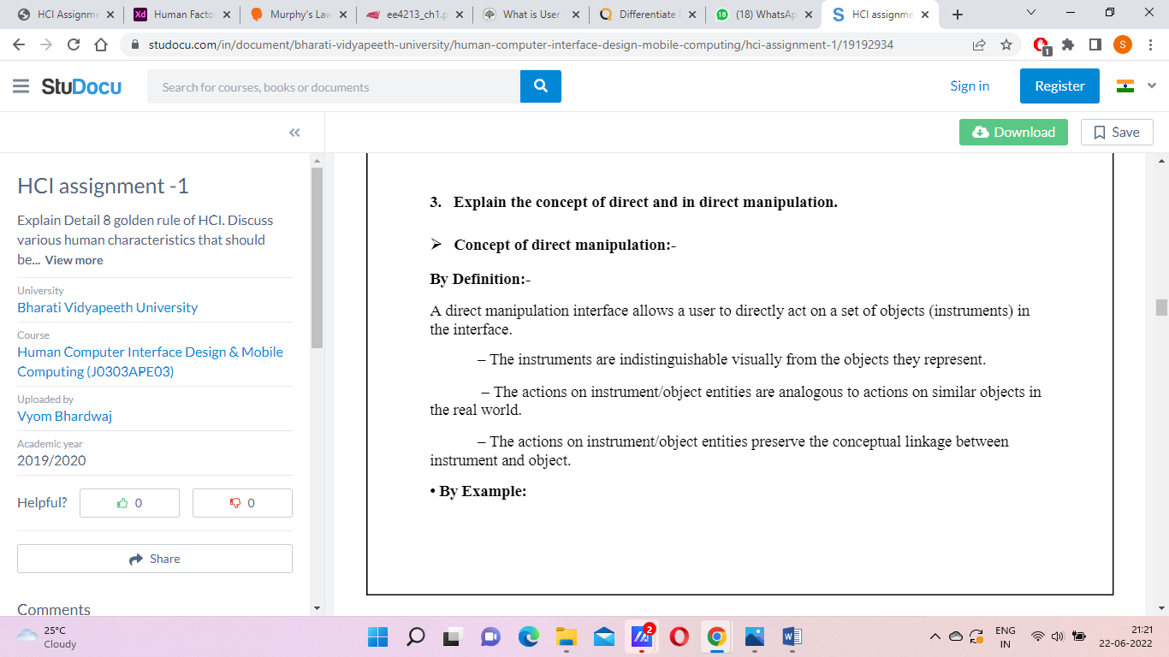

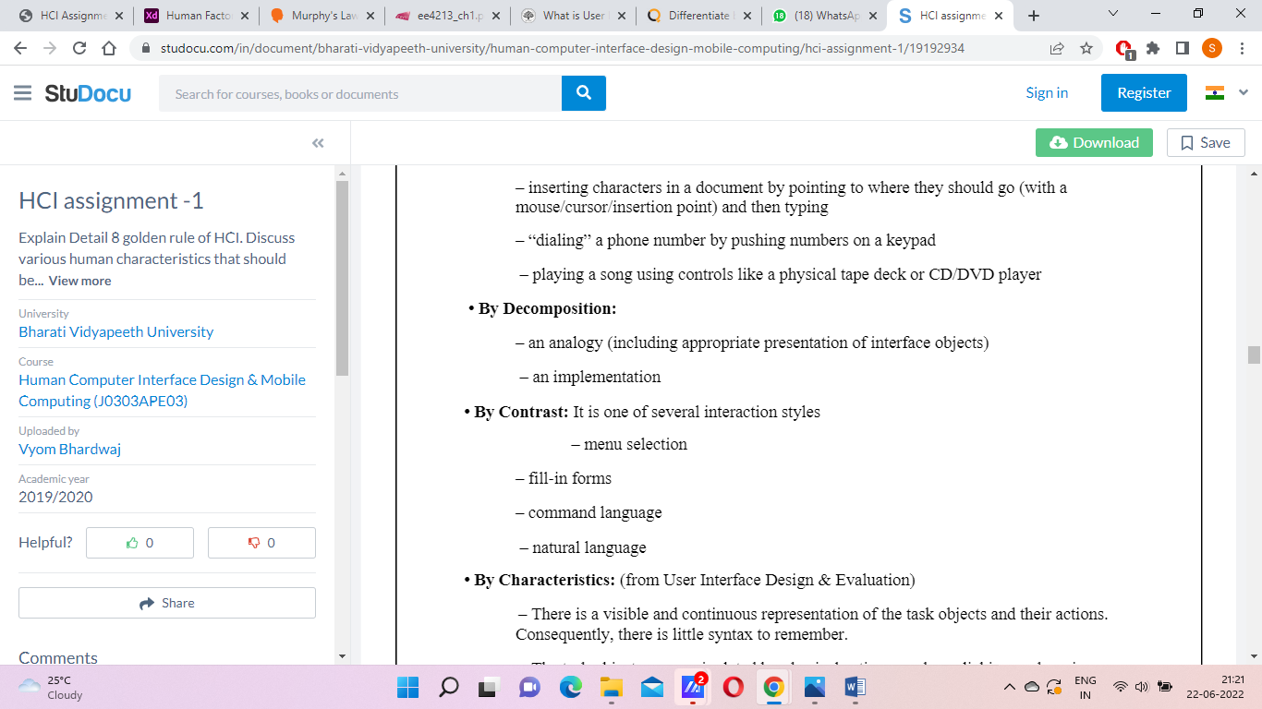

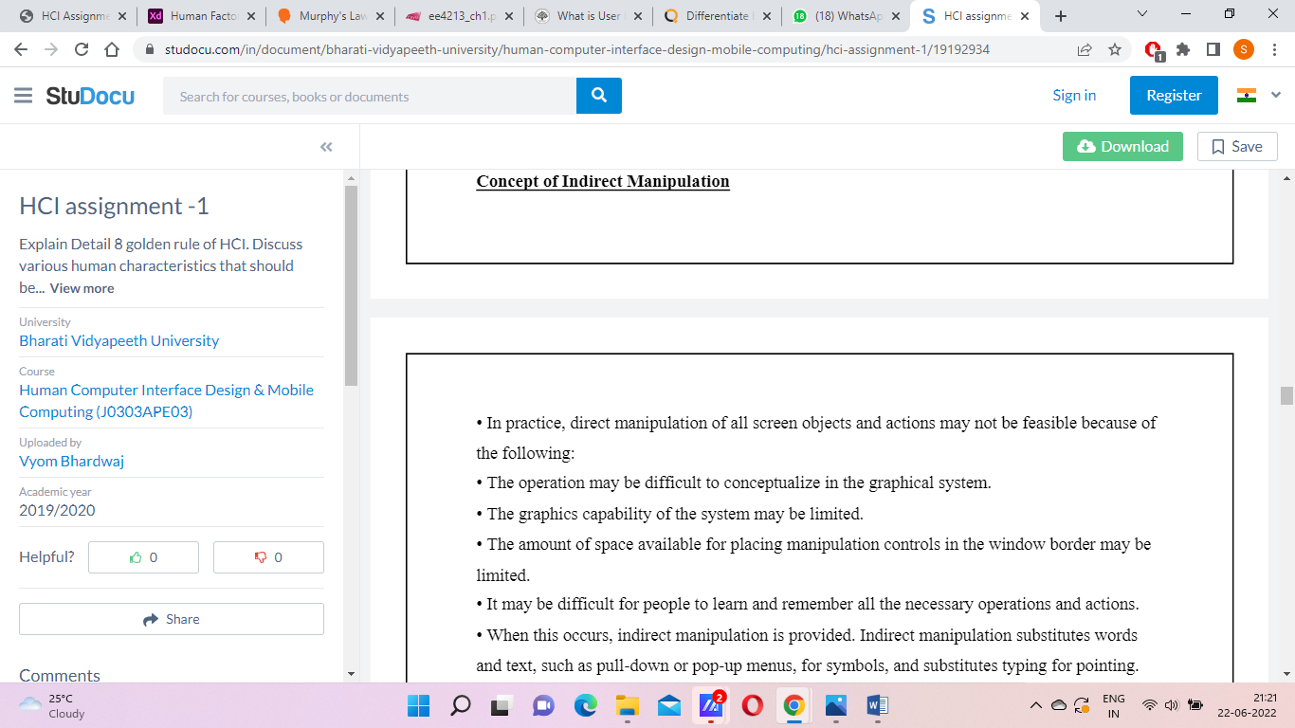

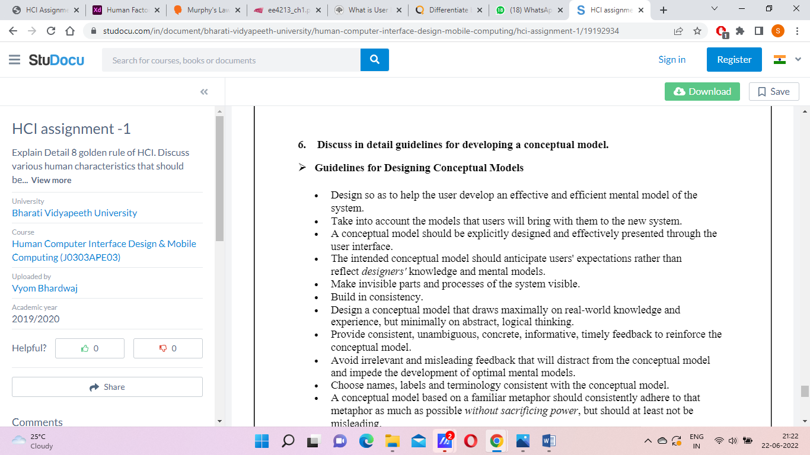

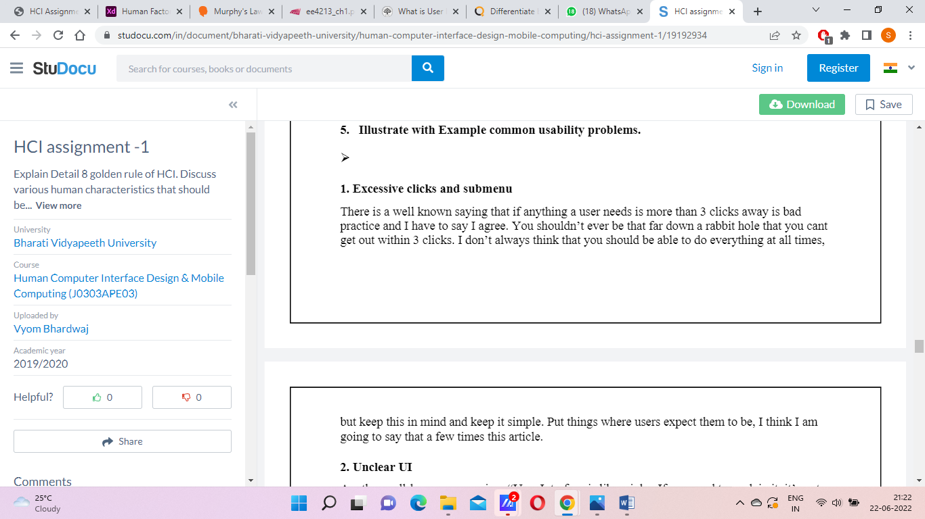

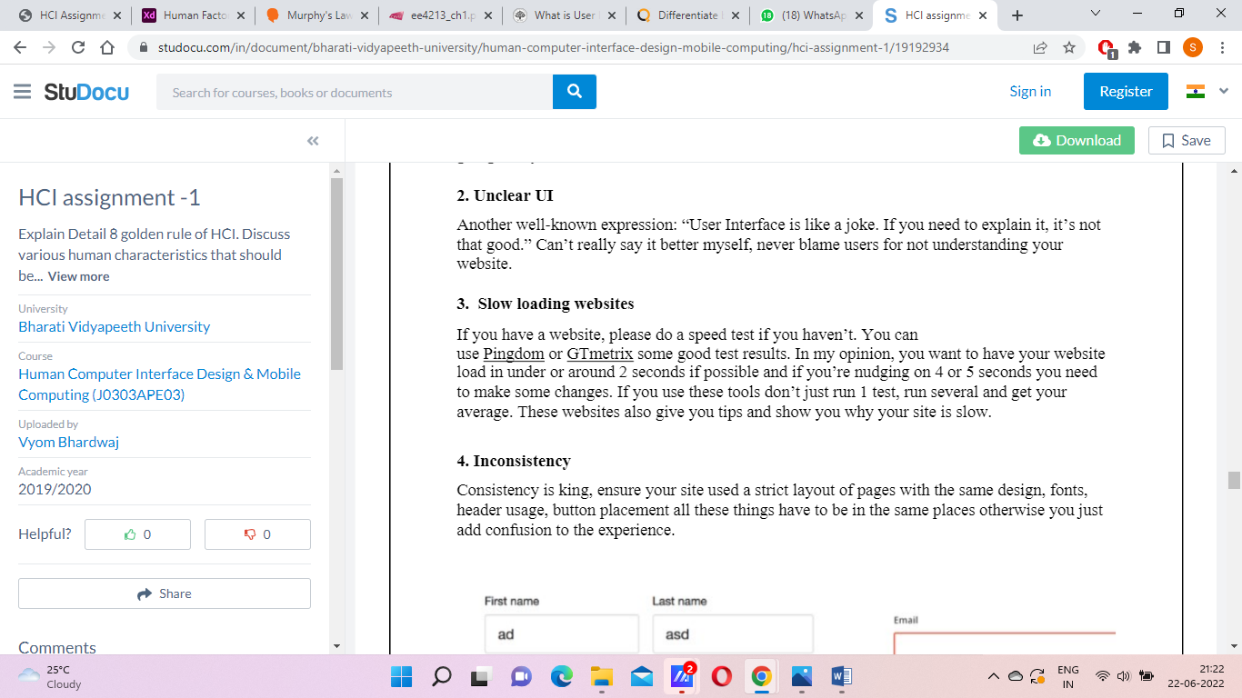

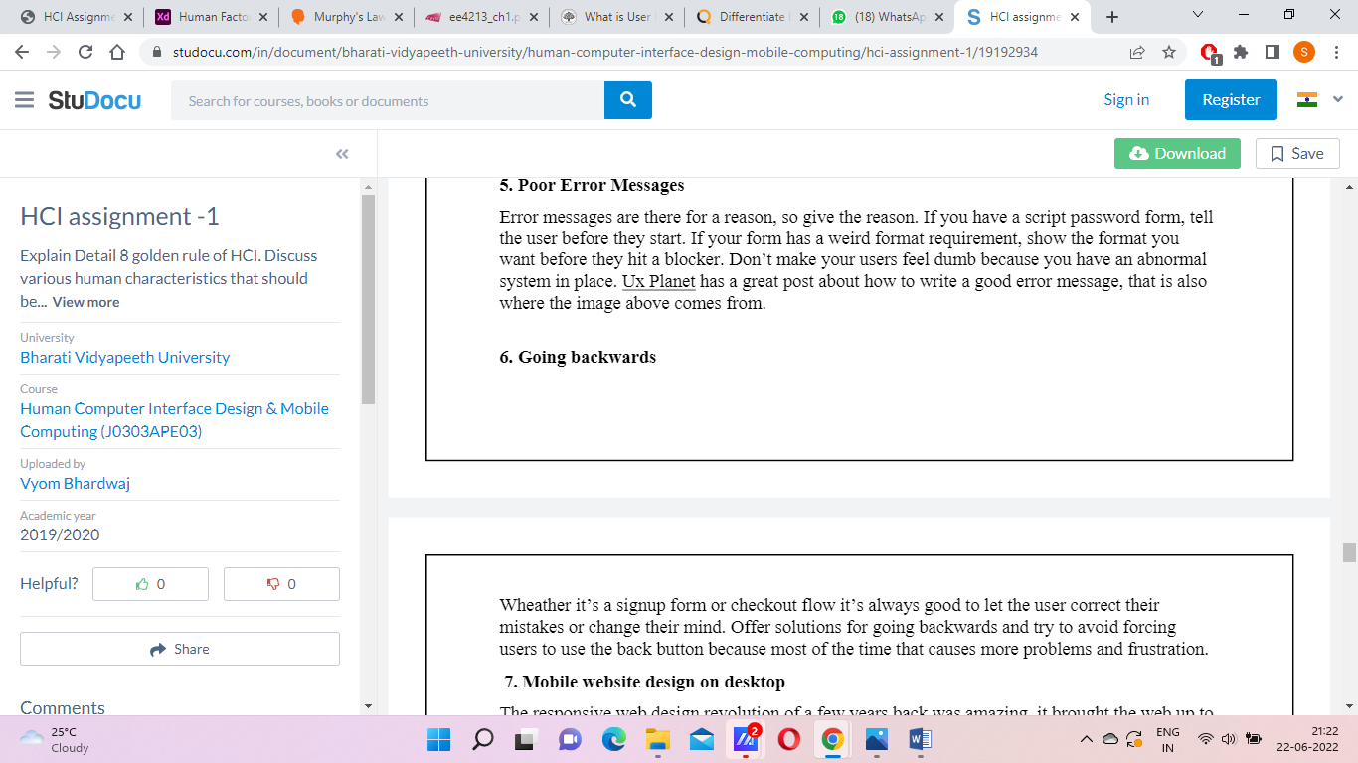

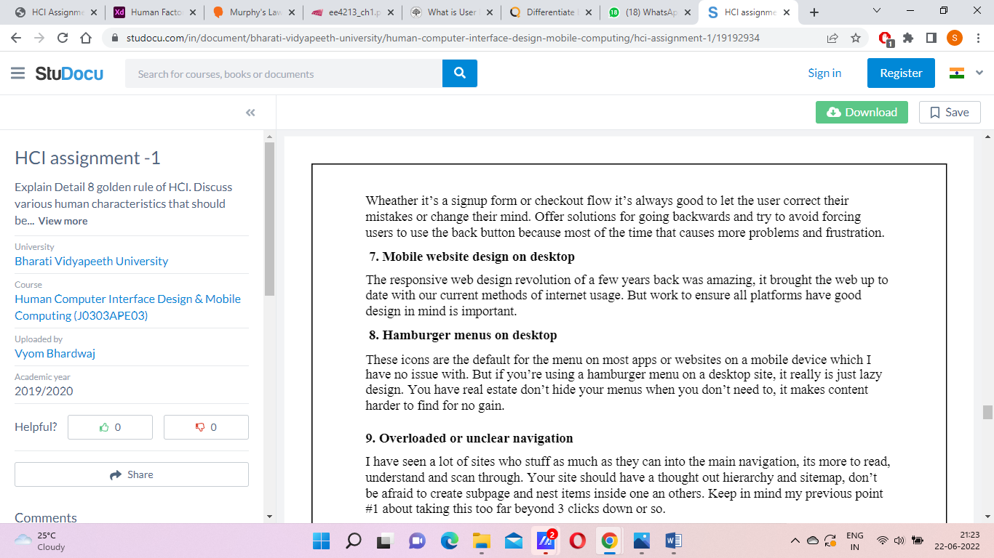

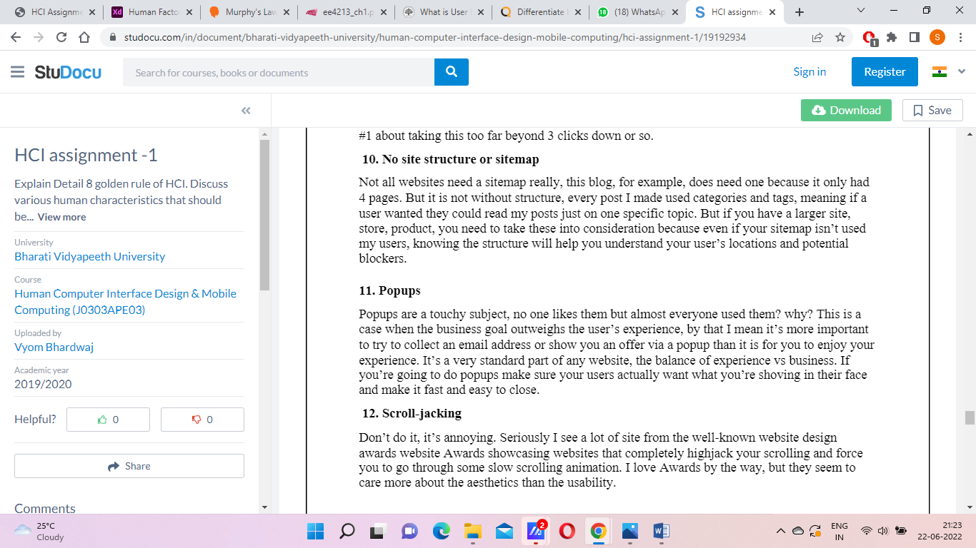

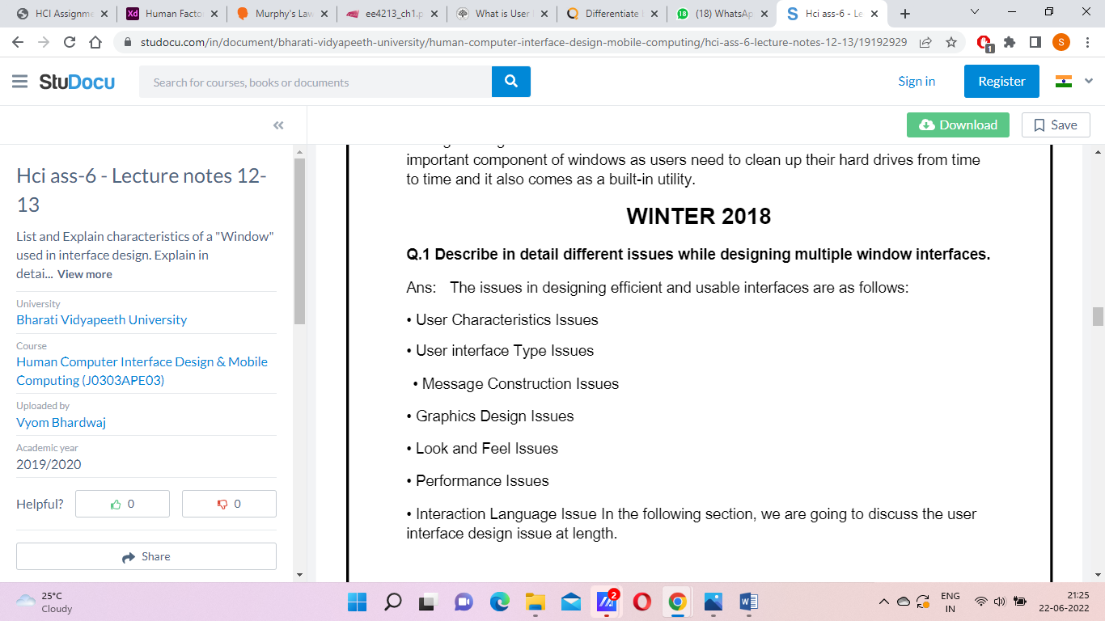

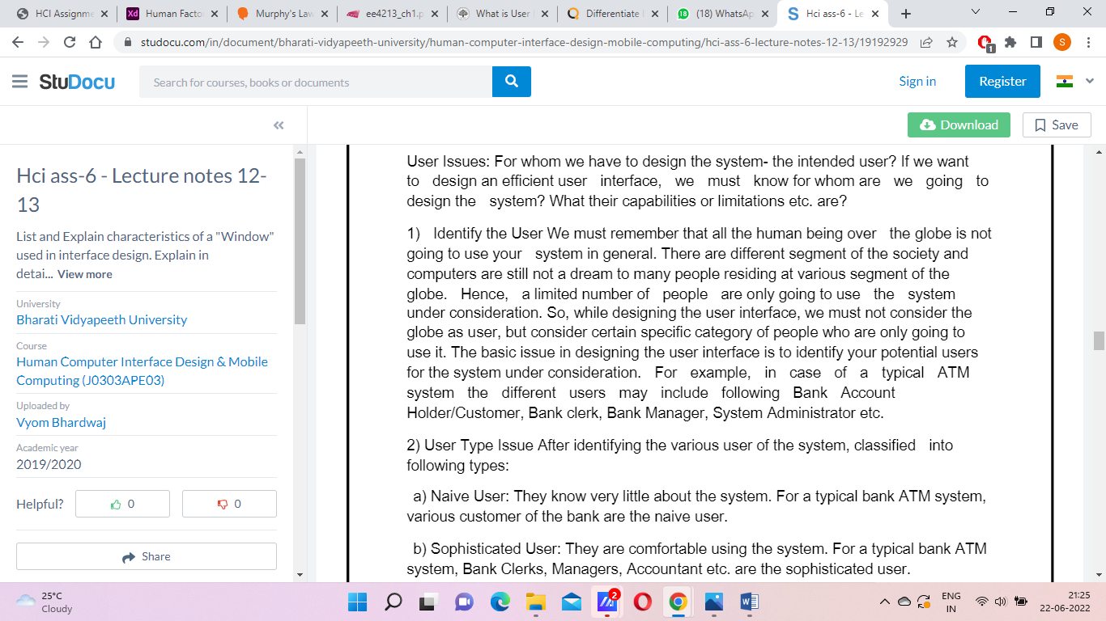

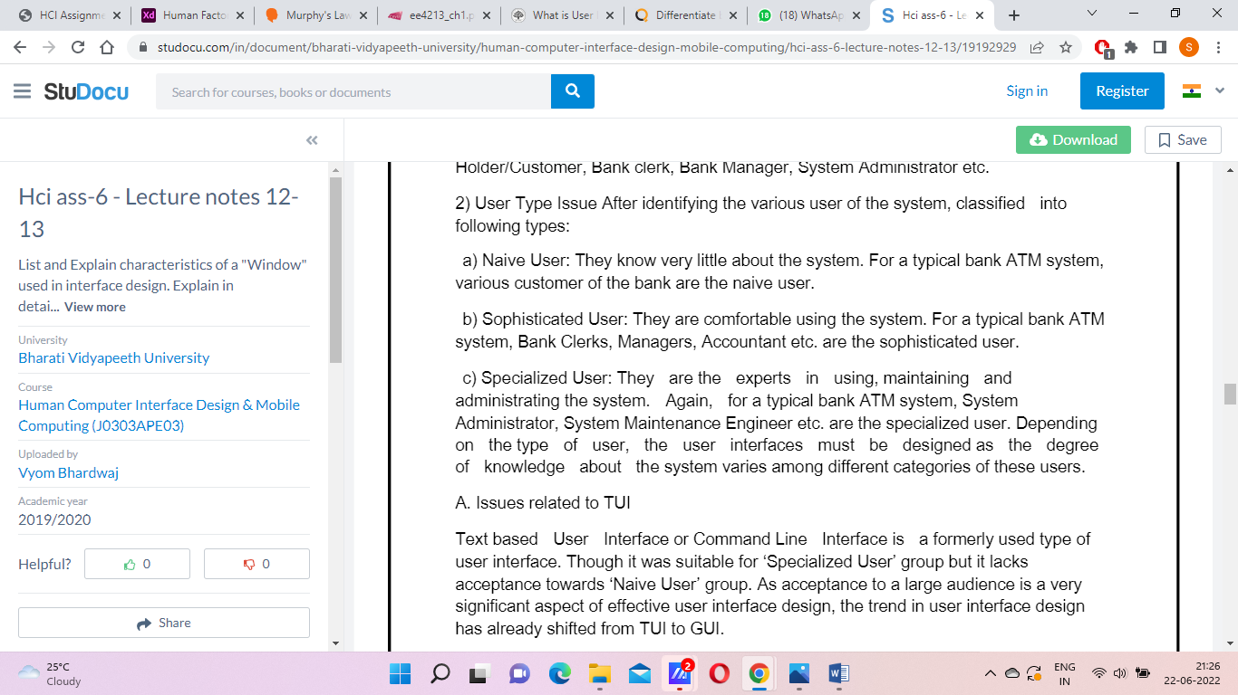

**3 pillars of design**

**2. Guidelines documents and processes**

Each project has different needs, but guidelines should be considered for:

1. Words, icons, and graphics

2. Screen-layout issues

3. Input and output devices

4. Action sequences

5. Training

**3. User-Interface Software Tools**

One difficulty in designing interactive systems is that customers and users may not have a clear idea of what the system will look like when it is done. Since interactive systems are novel in many situation, user may not realize the implications of design decisions. unfortunately, it is difficult, costly, and time-consuming to make major changes to systems once those systems have been implemented.

**4. Expert Reviews and Usability Testing**

In addition to a variety of expert review methods, test with the intended users, surveys, and automated analysis tools are proving to be valuable.

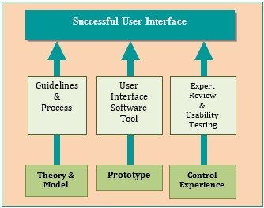

Screen Design Goals

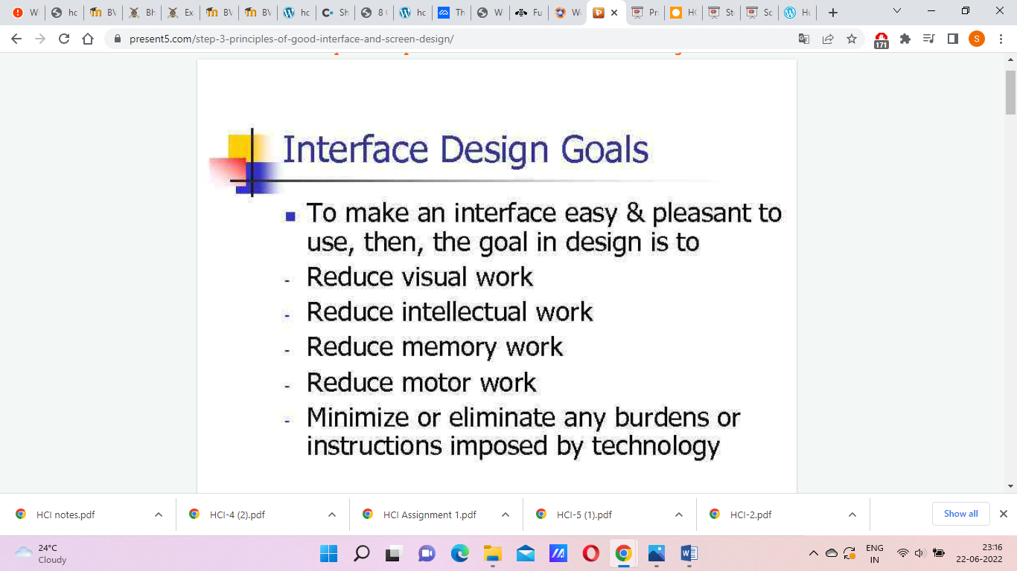

## Window Components

**Note:** To feel the window components, see the tactile foil A13.

Each window consists of several components:

* [the frame](https://www.lib.uom.gr/accelerate/ttu_en/gui_windows.html#The%20Frame)
* [the title bar](https://www.lib.uom.gr/accelerate/ttu_en/gui_windows.html#The%20Title%20Bar)
* [the menu bar](https://www.lib.uom.gr/accelerate/ttu_en/gui_windows.html#The%20Menu%20Bar)
* [the status bar](https://www.lib.uom.gr/accelerate/ttu_en/gui_windows.html#The%20Status%20Bar) and
* [the main window area](https://www.lib.uom.gr/accelerate/ttu_en/gui_windows.html#The%20main%20Window%20Area).

[](https://www.lib.uom.gr/accelerate/ttu_en/gui_windows.html#back_Window%20Components)

### 3.1 The Frame

The frame defines the resizable edges of a Window. Just as in reality, the size of  the frame of a Window defines the portion of information you can see at a moment.

[](https://www.lib.uom.gr/accelerate/ttu_en/gui_windows.html#back_The%20Frame)

### 3.2 The Title Bar

The title bar is at the very top of every window and it displays the title of the window. Normally the title of an application window contains also the name of the file open in the application, if any.

The Title Bar is colored blue, when the system has the focus on it (active Window) and light-gray, when it is in the background.

The title bar of any window displays an icon for its [Control Menu](https://www.lib.uom.gr/accelerate/ttu_en/gui_windows.html#w_control_menu)on the left hand side.

For windows which are sizeable the title bar also displays some standard icons on the very right-hand side:

* the minimize button  
  a little box with a horizontal rule in the lower part
* the maximize button (full screen or customize)  
  a little empty box  
  If the window is already maximized, the maximize button is replaced by the restore button  
  a box with two overlapping windows.  
  This button restores the window to its previous size.
* the close button  
  a box with an X on it.

[](https://www.lib.uom.gr/accelerate/ttu_en/gui_windows.html#back_The%20Title%20Bar)

### 3.3 The Menu Bar

[The menu bar](https://www.lib.uom.gr/accelerate/ttu_en/gui_vc.html#The%20Main%20Menu)is only found in application windows. It is a horizontal list of options for controlling all the activities of an application.

[](https://www.lib.uom.gr/accelerate/ttu_en/gui_windows.html#back_The%20Menu%20Bar)

### 3.4 The Status Bar

Some applications have a line (mostly at the bottom of the window) which displays different information about the status of the program.

This information can contain for example:

* the line and the column number of the current cursor position in a text
* the name of the currently active typing mode (INSERT or OVERWRITE)
* the content of the last deleted portion of text etc.

 The term direct manipulation is given by Shneiderman (1982) as they possess the following characteristics:

i. The system is portrayed as an extension of the real world.

ii. Continuous visibility of objects and actions.

iii. Actions are rapid and incremental with visible display of results.

iv. Incremental actions are easily reversible.

Example for direct manipulation:

**Driving an automobile**

The scene is directly visible through the front window and performance of actions such as braking or steering has become common knowledge in our culture. To turn left, the driver simply rotates the steering wheel to the left. The response is immediate and the scene changes, providing feedback to refine the turn.

In the above example, a driver looking at an object directly manipulates the scenario by his sudden action, which can be referred as direct manipulation.

**Indirect Manipulation**

In practice, direct manipulation of all screen objects and actions may not be feasible because of the following:

i. The operation may be difficult to conceptualize in graphical system.

ii. The graphics capability of the system may be limited.

iii. The amount of space available for placing manipulation controls in the window border may be limited.

iv. It may be difficult for people to learn and remember all the necessary operations and actions.

When this occurs, indirect manipulation is provided. Indirect manipulation substitutes words and text, such as pull-down or pop-up menus, for symbols and substitutes typing for pointing.

Most window systems are a combination of both direct manipulation and indirect manipulation. A menu may be accessed by pointing at a menu icon and then selecting it (direct manipulation) or the menu itself is a textual list of operations (indirect manipulation).